EXPT NO: 1 | BUILDING AND TRAINING A SIMPLE ARTIFICIAL NEURAL NETWORK (ANN) FOR REGRESSION AND CLASSIFICATION
DATE:

PRE-LAB QUESTIONS (PROVIDE BRIEF ANSWERS TO THE FOLLOWING QUESTIONS)
- What is an Artificial Neural Network (ANN)?
An Artificial Neural Network (ANN) is a machine learning model inspired by the human brain. It consists of interconnected neurons organized into layers that process input data, learn patterns through training, and make predictions or classifications. ANNs are widely used in applications such as image recognition, speech processing, and predictive analytics.
- What are the functions of the input, hidden, and output layers in an ANN?
The input layer receives the input features and passes them to the network. The hidden layers process the information by learning patterns and relationships using weights and activation functions. The output layer produces the final prediction or classification result based on the processed information from the hidden layers.
- Why is feature scaling important before training an ANN?
Feature scaling ensures that all input features are on a similar scale, preventing features with larger values from dominating the learning process. It improves the speed and stability of training, helps gradient descent converge faster, and leads to better model accuracy and overall performance.
- Differentiate between regression and classification problems with examples.
Regression predicts continuous numerical values, such as house prices or temperature. Classification predicts discrete categories or labels, such as spam or non-spam emails, or whether a tumor is benign or malignant. Regression outputs numbers, while classification outputs class labels based on the learned patterns.
- What is the role of the activation function in a neural network?
The activation function introduces non-linearity into the neural network, allowing it to learn complex relationships in data. It determines whether a neuron should be activated and pass information to the next layer. Common activation functions include ReLU, Sigmoid, and Softmax, depending on the application.

AIM
To understand the implementation of Artificial Neural Networks (ANN) using TensorFlow and evaluate their performance on regression and classification problems.

SOFTWARE REQUIREMENTS
- Python 3.x
- Google Colab / Jupyter Notebook
- TensorFlow 2.x
- NumPy
- Pandas
- Matplotlib
- Scikit-learn

LEARNING OBJECTIVES
After completing this experiment, students will be able to:
- Understand the architecture of an Artificial Neural Network.
- Build an ANN for regression problems.
- Build an ANN for classification problems.
- Train and evaluate neural network models.
- Compare different evaluation metrics used for regression and classification.

Task A – ANN FOR REGRESSION
DATASET: California Housing Dataset
SOURCE: Scikit-learn
DESCRIPTION
- Samples: 20,640
- Features: 8
- Target: Median House Value

FEATURES
Feature | Description
MedInc | Median Income
HouseAge | House Age
AveRooms | Average Rooms
AveBedrms | Average Bedrooms
Population | Population
AveOccup | Average Occupancy
Latitude | Latitude
Longitude | Longitude

ALGORITHM
- Import libraries.
- Load California Housing dataset.
- Split into training and testing sets.
- Standardize the features.
- Build ANN model.
- Compile the model.
- Train the model.
- Predict house prices.
- Evaluate using:
  - MSE
  - MAE
  - RMSE

Output Screenshots:

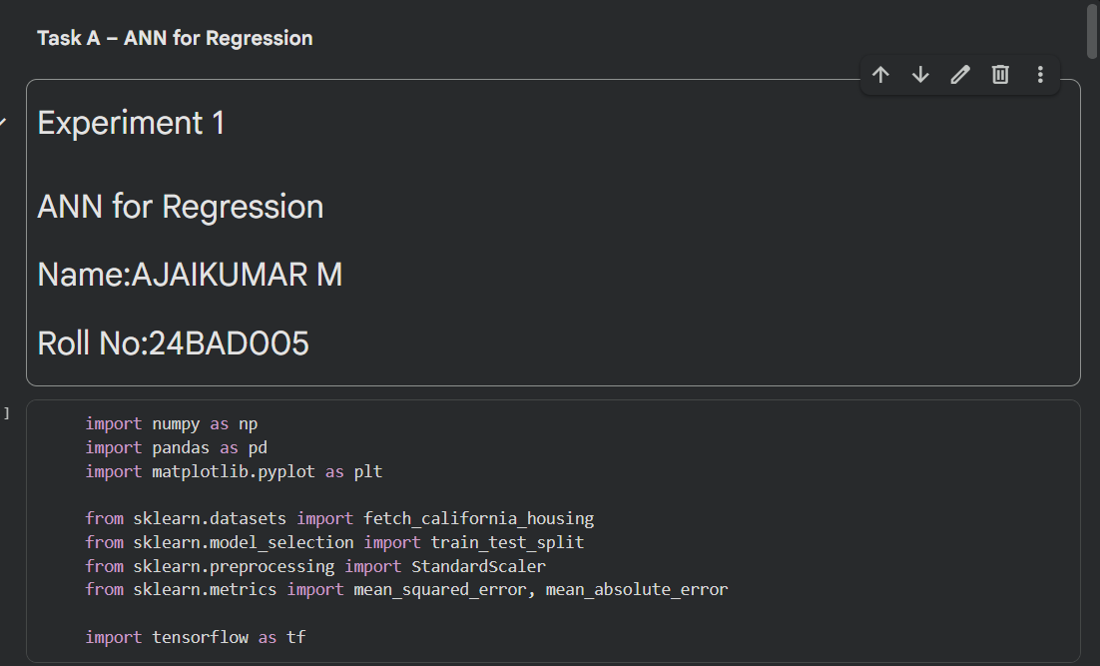
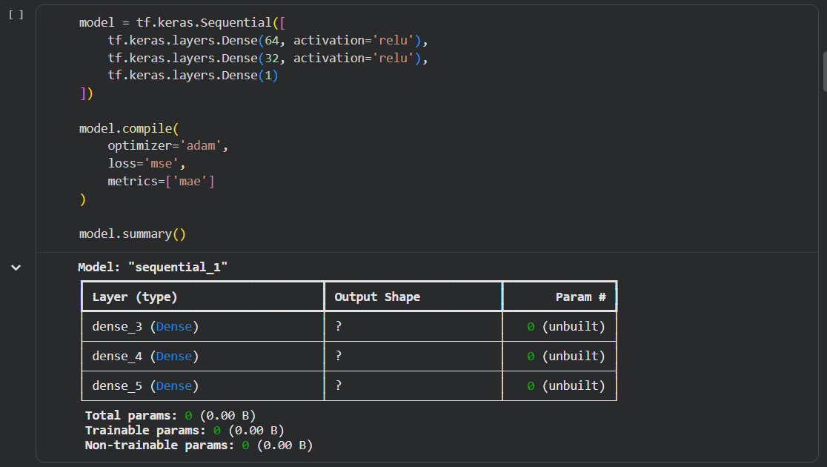

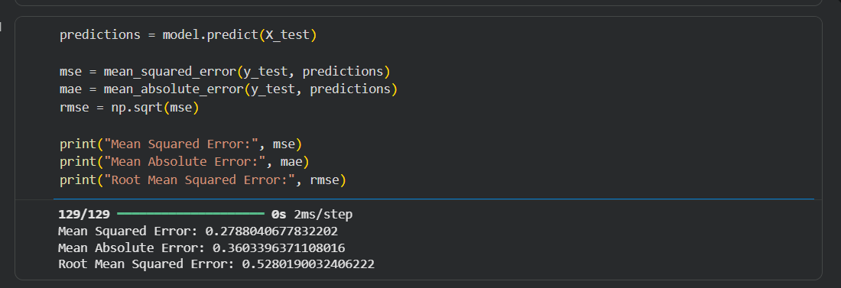

Task B – ANN FOR CLASSIFICATION
DATASET: Breast Cancer Wisconsin Dataset
SOURCE: Scikit-learn
DESCRIPTION
- Samples: 569
- Features: 30
- Classes:
  - Malignant
  - Benign

ALGORITHM
- Import libraries.
- Load Breast Cancer dataset.
- Split dataset.
- Standardize features.
- Design ANN.
- Compile model.
- Train model.
- Predict labels.
- Evaluate:
  - Accuracy
  - Precision
  - Recall
  - F1-score
  - Confusion Matrix

Output Screenshots:

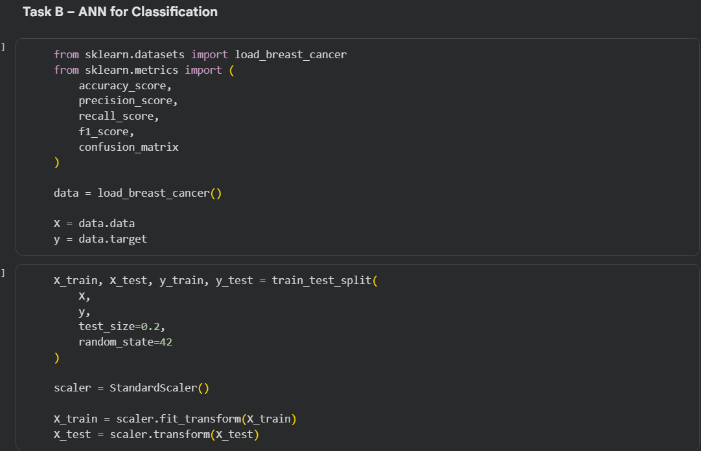
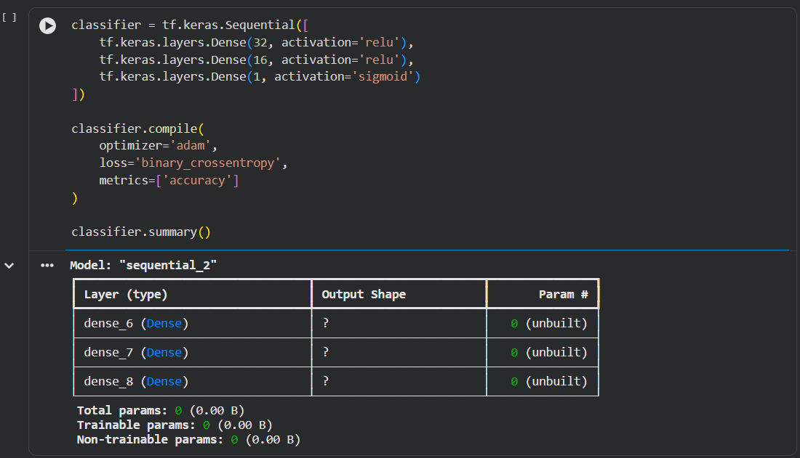

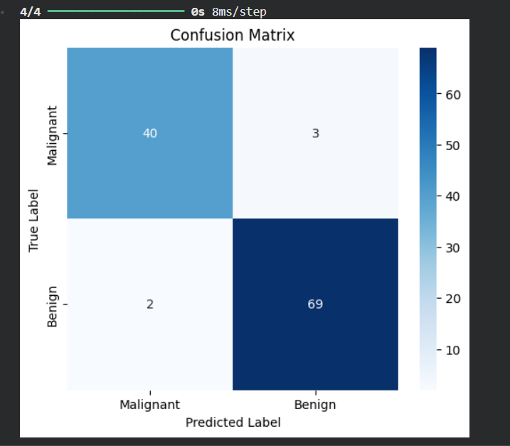

POST-LAB QUESTIONS (PROVIDE BRIEF ANSWERS TO THE FOLLOWING QUESTIONS)

- Why is the Adam optimizer commonly used in ANN training?
The Adam optimizer is widely used because it combines the advantages of momentum and adaptive learning rates. It updates model weights efficiently, speeds up convergence, and performs well on large and complex datasets. Adam requires minimal parameter tuning and provides stable training with improved accuracy.

- Compare Mean Squared Error (MSE) and Mean Absolute Error (MAE). Which metric is more sensitive tooutliers?
Mean Squared Error (MSE) calculates the average of squared prediction errors, while Mean Absolute Error (MAE) calculates the average of absolute prediction errors. MSE gives more weight to larger errors, making it more sensitive to outliers. MAE is less affected by extreme values and is easier to interpret.

- Why is the sigmoid activation function used in binary classification?
The sigmoid activation function is used in binary classification because it converts the output into a probability value between 0 and 1. This probability helps determine the predicted class by applying a threshold, usually 0.5. It is simple, effective, and suitable for problems with two classes.

- How does increasing the number of hidden layers affect the performance of an ANN?
Increasing the number of hidden layers enables an ANN to learn more complex patterns and improve performance on difficult tasks. However, too many hidden layers may increase training time, computational cost, and the risk of overfitting. Choosing an appropriate network depth is important for achieving good performance.

- Compare the evaluation metrics used for regression and classification tasks. Why are different metrics required for these problems?
Regression models are evaluated using metrics such as MSE, MAE, and RMSE, which measure prediction errors for continuous values. Classification models use Accuracy, Precision, Recall, F1-score, and Confusion Matrix to evaluate class predictions. Different metrics are required because regression predicts numerical values, while classification predicts discrete categories.

GitHub Link:

ASSESSMENT
Description | Max Marks | Marks Awarded
Pre Lab Exercise | 5
In Lab Exercise | 10
Post Lab Exercise | 5
Viva | 10
Total | 30
Faculty Signature

